Splicing Solutions for the SMT Industry

Complete line of tape splices, cover tape extenders and tools. Examples of a variety of parts and tools are
show below. If you don’t see what you are looking for, please contact us as we are always adding new items.

*** No charge samples are available for evaluation upon request ***

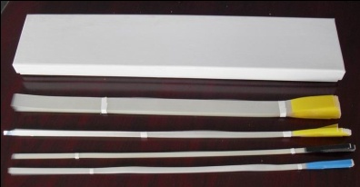
Cover Tape Extenders Super Double Splice Tape Super Double Splice Tape Super Double Splice Tape
(w/outside dimples) (w/edge guide) (w/edge guide and dimples)
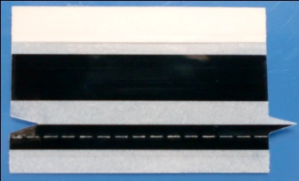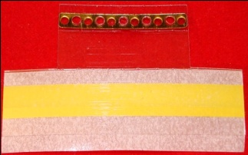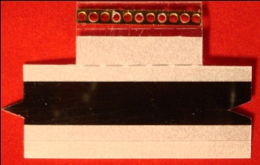
Double Splice Tape Special Tape w/edge guide Clip and Splice Tape Clip and Special Tape Special Splice Tape

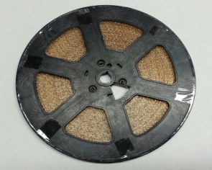 Single Splice Tape Single Splice Single Splice Tapes Single Splice Tape Single Splice Tapes - Reel Brass Clips - Reel
(multi-up card)

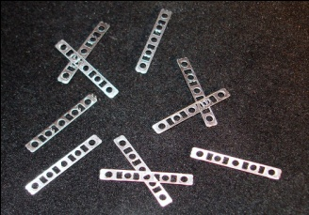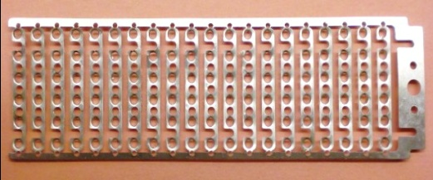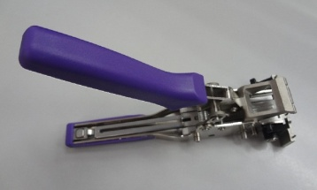
Brass Splice Clips Steel Splice Clips Brass Strips in Frame Splice Stapler used with
brass strips in frame

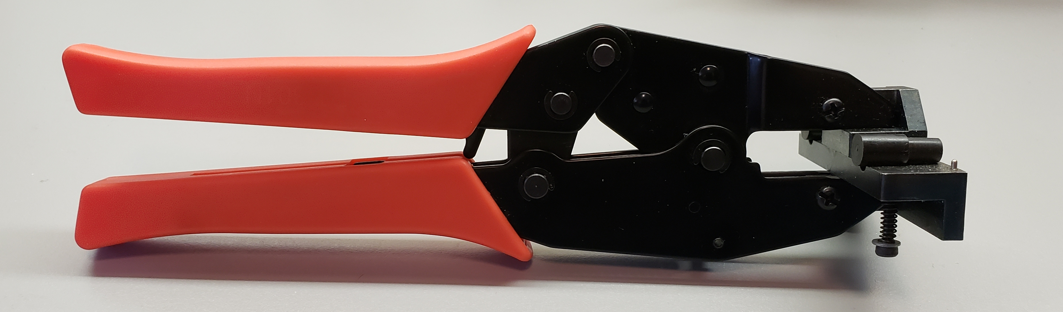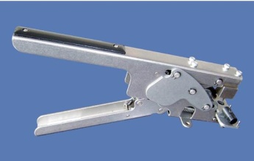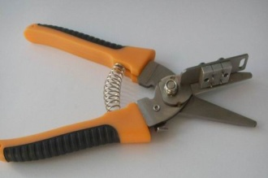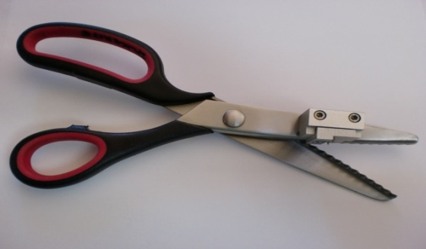
Splice Tool for joining Splice Tool for joining Cutting scissors w/guide Tape Cutter w/guide Tape Cutter
carrier tapes w/clips carrier tapes w/clips

SpliceRite - Owned and Distributed by Tonka Electronics, Inc. • 10335 Colorado Road • Bloomington, Minnesota 55438-1863
Phone: (952) 831-8969 • Fax: (952) 831-3681 • email: sales@tonkaelectronics.com
www.splicerite.com • www.tonkaelectronics.com

